KENDRIYA VIDYALAYA GOALPARA
Time table for Online Classes(VI-XII)

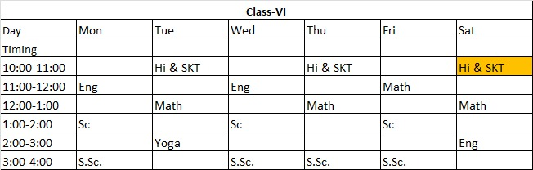

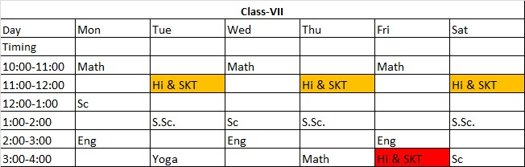

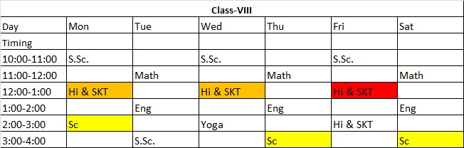

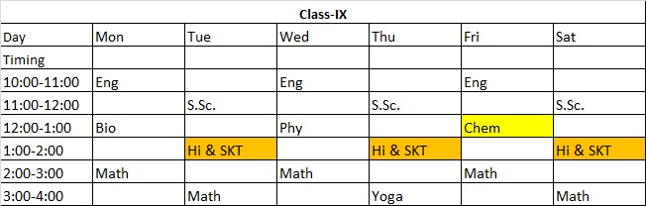

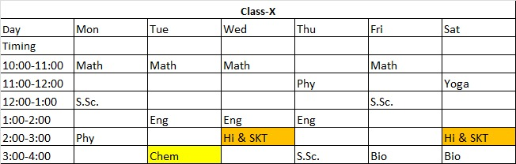

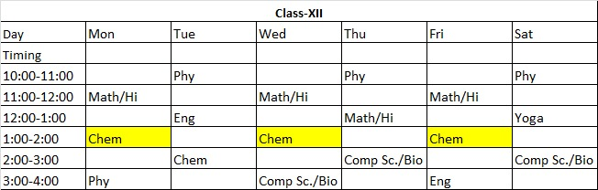
Principal
Sh. Ajit Singh

